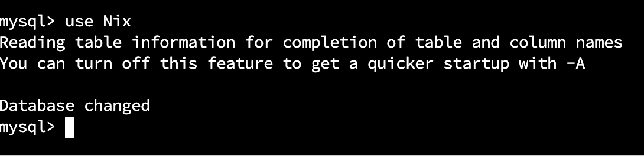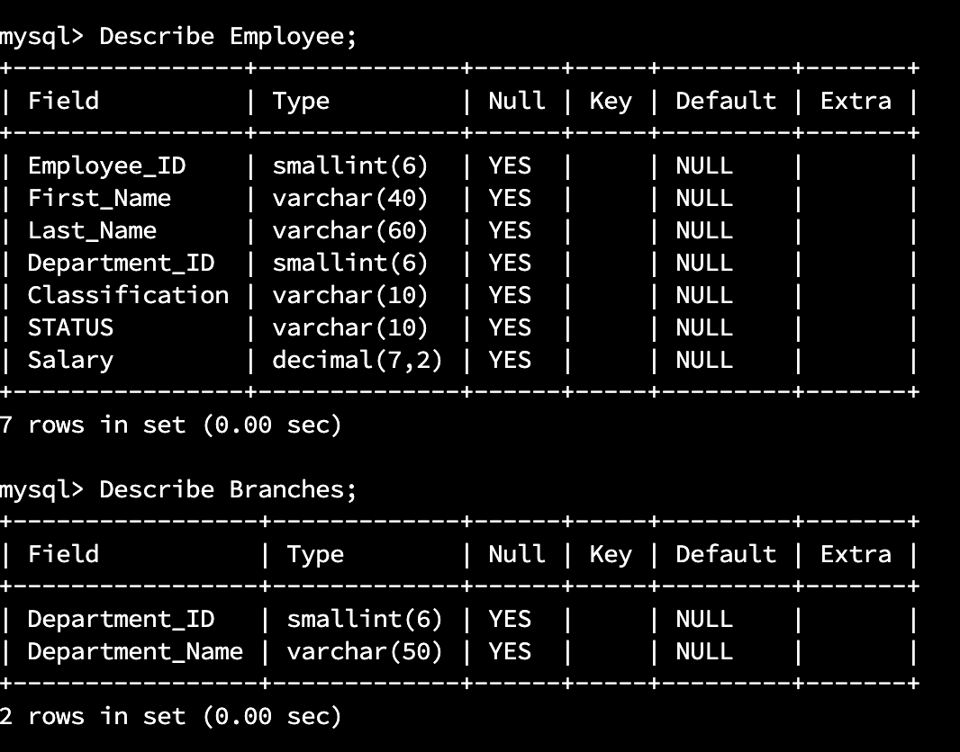

The **desc** or **describe** command shows a table's structure, which includes the column's name, the **data-type** of the column, and the **nullability.**

